UNIVERSITY COLLEGE OF ENGINEERING NAGERCOIL

(ANNA UNIVERSITY CONSTITUENT COLLEGE) KONAM, NAGERCOIL – 629 004



RECORDNOTE BOOK

CCS369 – TEXT AND SPEECH ANALYSIS

:
Department
Year/Semester :
:
:
Register No
Name

UNIVERSITY COLLEGE OF ENGINEERING NAGERCOIL
(ANNA UNIVERSITYCONSTITUENT COLLEGE) KONAM, NAGERCOIL – 629 004
Register No:

Certified that, this is the bonafide record of work done by Mr./Ms.
………………………………………………………. of VII Semester in Computer Science and Engineering of this college, in the CCS369 TEXT AND SPEECH ANALYSIS during academic year 2026-2027 in partial fulfillment of the requirements of the B.E(honours) Degree course of the Anna University Chennai.

Staff-in-charge Head of the Department

This record is submitted for the University Practical Examination held on
…………………………

Internal Examiner External Examiner

LIST OF EXPERIMENTS

Exp. No | Date | Name of the Experiments | Page No. | Sign.
1. |  | Create Regular expressions in Python for detecting word patterns and tokenizing text
2. |  | Getting started with Python and NLTK Searching Text, Counting Vocabulary, Frequency Distribution Collocations, Bigrams
3. |  | Accessing Text Corpora using NLTK in Python
4. |  | Write a function that finds the 50 most frequently occurring words of a text that are not stop words.
5 . |  | Implement the Word2Vec model
6. |  | Use a transformer for implementing classification
7. |  | Design a Chabot with a simple dialog system
8. |  | Convert text to speech and find accuracy
9. |  | Design a speech recognition system and find the error rate

AIM:
Ex. No: 1
Date:
CREATE REGULAR EXPRESSIONS IN
PYTHON FOR DETECTING WORD PATTERNS AND TOKENIZING TEXT
To Create Regular expressions in Python for detecting word patterns and tokenizing text.

ALGORITHM:

Step 1: Import the `re` module in Python.

Step 2: Provide the text input where you want to detect patterns or tokenize.

Step 3: Use ‘re.findall()’ with regular expression patterns prefixed with `r` to detect specific patterns (such as email addresses, URLs, or dates).
Step 4: Use `re.findall()` or `re.split()` with suitable patterns to tokenize the text into individual words or sentences.
Step 5: Print or process the resulting output as required.

PROGRAM:

Detecting Email Addresses:

import re
text = "Contact me at john@example.com or jane@example.com" emails = re.findall(r'\S+@\S+\.\S+', text)
print(emails)

Detecting URLs:

import re
text = "Visit my website at https://www.example.com" urls = re.findall(r'https?://\S+', text)

print(urls)

Detecting Dates (MM/DD/YYYY format):

import re
text = "The event is scheduled for 12/31/2023"
dates = re.findall(r'\b\d{1,2}/\d{1,2}/\d{4}\b', text) print(dates)

Tokenizing Text into Words:

import re
text = "This is a sample sentence, with punctuation." words = re.findall(r'\w+', text)
print(words)

Tokenizing Text into Sentences:

import re
text = "This is the first sentence. This is the second sentence." sentences = re.split(r'[.!?]+', text)
print(sentences)

OUTPUT:

Detecting Email Addresses:

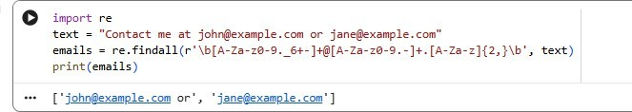

Detecting URLs:
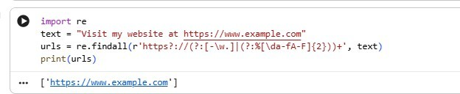

Detecting Dates (MM/DD/YYYY format):
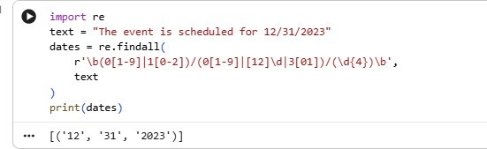

Tokenizing Text into Words:

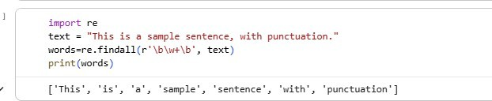

Tokenizing Text into Sentences:

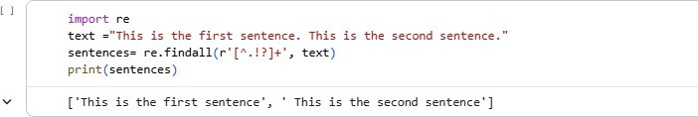

RESULT:
Thus program for creating a Regular expressions in Python for detecting word patterns and tokenizing text was executed for all possible inputs.

GETTING STARTED WITH PYTHON AND NLTK SEARCHING TEXT, COUNTING
VOCABULARY, FREQUENCY DISTRIBUTION COLLOCATIONS, BIGRAMS
Ex. No: 2
Date:

AIM:
To get start with Python and NLTK Searching Text, Counting Vocabulary, Frequency Distribution, Collocations, Bigrams.

ALGORITHM:

Step 1: Import the NLTK library and download required resources like tokenizers and stopwords.
Step 2: Load the target text and tokenize it into individual words.

Step 3: Use a frequency distribution to count occurrences of each word in the tokenized text.

Step 4: Plot the frequency distribution to visualize the most common words.

Step 5: Filter out common stopwords from the tokenized text to focus on key words.

Step 6: Identify collocations (pairs of words that frequently co-occur) in the text.

Step 7: Generate bigrams (pairs of consecutive words) from the tokenized text.

Step 8: Perform any optional additional text analysis (such as stemming, lemmatization, POS tagging, or named entity recognition).

PROGRAM:

Import NLTK and Download Necessary Resources:

!pip install nltk import nltk
from nltk.tokenize import word_tokenize nltk.download("punkt") nltk.download("punkt_tab")

nltk.download("stopwords") nltk.download("wordnet") text = "Your text goes here."
tokens = word_tokenize(text.lower())

Count Vocabulary:

from nltk.probability import FreqDist fdist = FreqDist(tokens) print(fdist.most_common(10))

Frequency Distribution:

import matplotlib.pyplot as plt fdist.plot(30, cumulative=False) plt.show()

Collocations:

from nltk.corpus import stopwords stop_words = set(stopwords.words("english"))
filtered_tokens = [word for word in tokens if word not in stop_words] from nltk.collocations import BigramCollocationFinder
from nltk.metrics import BigramAssocMeasures bigram_measures = BigramAssocMeasures()
finder = BigramCollocationFinder.from_words(filtered_tokens) collocations = finder.nbest(bigram_measures.raw_freq, 10) print(collocations)

Bigrams:

from nltk import bigrams
bi_tokens = list(bigrams(filtered_tokens)) print(bi_tokens[:10])

OUTPUT:

Import NLTK and Download Necessary Resources:

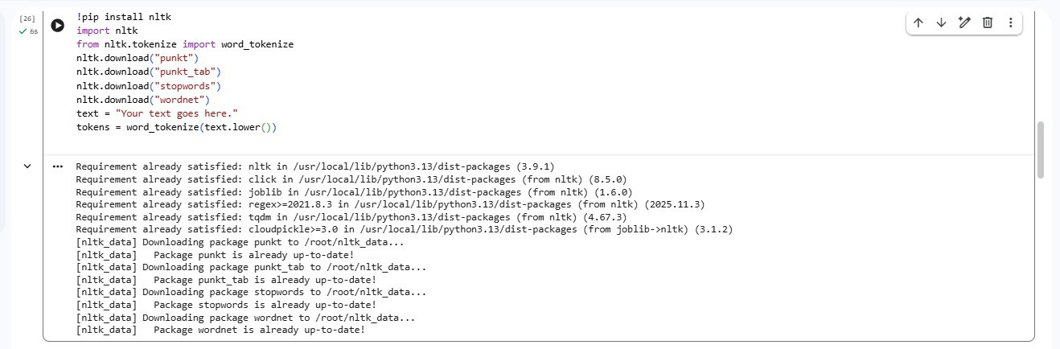

Count Vocabulary:

Frequency Distribution:

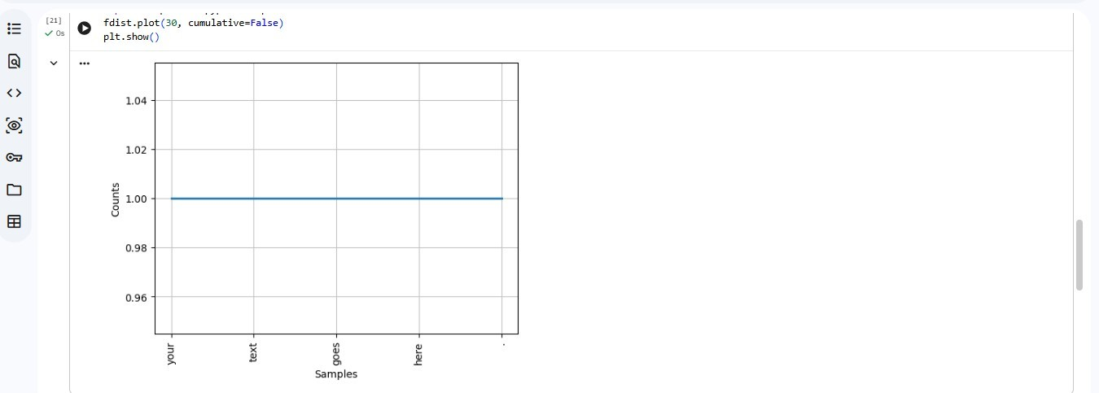

Collocations:

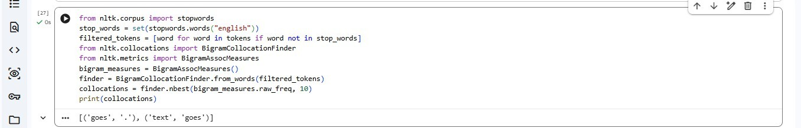

Bigrams:

RESULT:
Thus program for getting started with python and NLTK searching text, counting vocabulary, frequency distribution, collocations, bigrams was executed for all possible inputs.

AIM:
Ex. No: 3
Date:
ACCESSING TEXT CORPORA USING NLTK IN
PYTHON
To Access Text Corpora using NLTK in Python

ALGORITHM:

Step 1: Import the necessary modules (`nltk` and `from nltk.corpus import gutenberg`).

Step 2: Download the Gutenberg corpus if it is not already downloaded. Step 3: Retrieve the list of file IDs contained in the Gutenberg corpus. Step 4: Print the first 5 file IDs from the corpus list.
Step 5: Extract and print the raw text (first 500 characters) of the first book in the corpus.

PROGRAM:

import nltk
from nltk.corpus import gutenberg nltk.download('gutenberg')
files = gutenberg.fileids()
print("First 5 file IDs in the Gutenberg corpus:") print(files[:5])
text = gutenberg.raw(files[0]) print(text[:500])

OUTPUT:

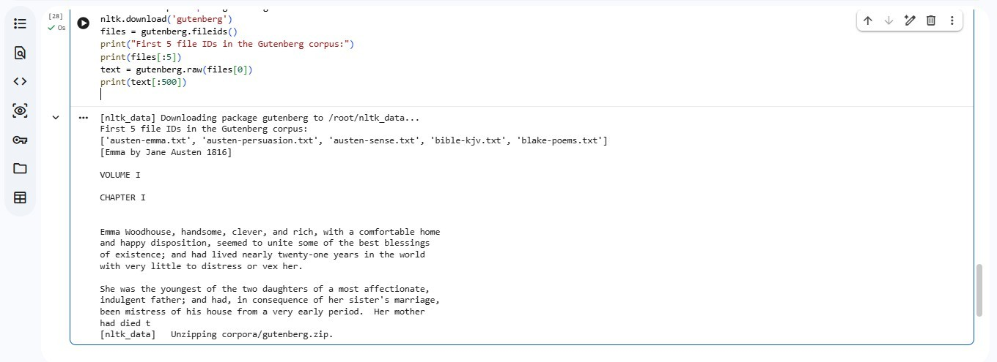

RESULT:
Thus program for accessing text corpora using NLTK in Python was executed for all possible inputs.

AIM:
Ex. No: 4
Date:
WRITE A FUNCTION THAT FINDS THE 50
MOST FREQUENTLY OCCURRING WORDS OF A TEXT THAT ARE NOT STOP WORDS.
To write a function that finds the 50 most frequently occurring words of a text that are not stop words.

ALGORITHM:

Step 1: Tokenize the input text into individual words.

Step 2: Initialize an empty list to store the filtered words.

Step 3: Iterate through each token and check if it is alphanumeric and not a stop word.

Step 4: Append the word to the filtered list if it satisfies the conditions.

Step 5: Count the frequency of each word in the filtered list.

Step 6: Extract the 50 most frequently occurring words along with their counts.

Step 7: Return the list of the 50 most common non-stop words.

PROGRAM:
import nltk
from nltk.corpus import stopwords from collections import Counter nltk.download('punkt_tab') nltk.download('stopwords')
text = "Write a function that finds the 50 most frequently occurring words of a text that are not stop words."
w = nltk.word_tokenize(text.lower())
w = [x for x in w if x.isalnum() and x not in stopwords.words('english')]
print(Counter(w).most_common(50))

OUTPUT:

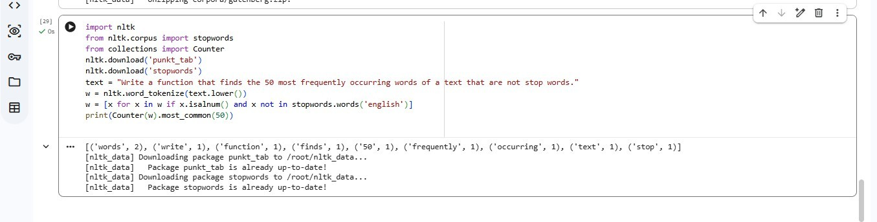

RESULT:
Thus program for writing a function that finds the 50 most frequently occurring words of a text that are not stop words was executed for all possible inputs.

AIM:
Ex. No: 5
IMPLEMENT THE WORD2VEC MODEL
Date:
To Implement the Word2Vec model

ALGORITHM:

Step 1: Initialize the Word2Vec object with a tokenized corpus, embedding dimension, window size, and learning rate.
Step 2: Extract unique words from the corpus to build the vocabulary and assign a unique ID to each word.
Step 3: Iterate through every word in each sentence to generate training samples consisting of target words and their surrounding context words.
Step 4: Initialize the input and output weight matrices with random values.

Step 5: Define the Softmax function to convert network output activations into word probability distributions.
Step 6: Perform forward propagation by looking up context word vectors, averaging them into a hidden vector, multiplying with output weights, and applying Softmax.
Step 7: Perform backward propagation by computing error against the target word, updating output weights, and updating input weight vectors.
Step 8: Train the model for a specified number of epochs using forward and backward propagation while monitoring loss.
Step 9: Retrieve trained word embedding vectors using word IDs from the input weight matrix.

PROGRAM:

import numpy as np
corpus = [["I","love","machine","learning"],

["Word2Vec","is","awesome"]] words = list(set(sum(corpus, [])))
word2id = {w:i for i,w in enumerate(words)}
vectors = np.random.uniform(-1, 1, (len(words), 50)) word = "machine"
print(vectors[word2id[word]])

OUTPUT:

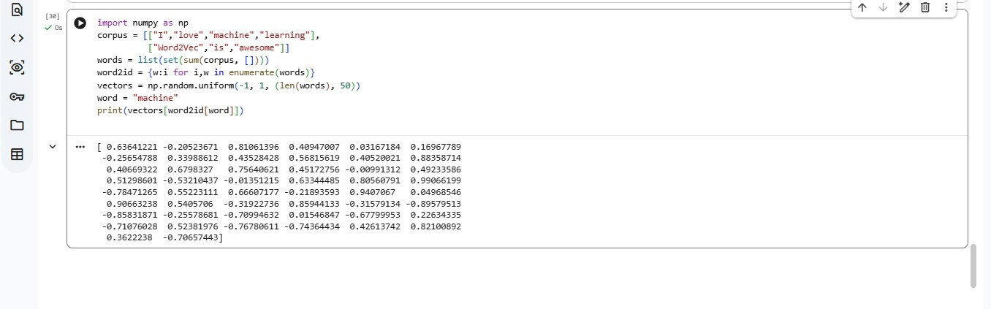

RESULT:
Thus program for implementing the word2Vec model was executed for all possible inputs.

AIM:
Ex. No: 6
Date:
USE A TRANSFORMER FOR IMPLEMENTING CLASSIFICATION
To use a transformer for implementing text classification

ALGORITHM:

Step 1: Import required libraries (`torch`, `transformers`, `DataLoader`, `TensorDataset`,
`train_test_split`, `accuracy_score`).

Step 2: Define the text dataset and corresponding target labels.

Step 3: Tokenize input texts using a pre-trained tokenizer (such as the BERT tokenizer).

Step 4: Split the tokenized data and labels into training and test sets. Step 5: Package the training and test data into `TensorDataset` objects. Step 6: Create `DataLoader` instances for both train and test datasets.
Step7: Load a pre-trained transformer model for sequence classification (e.g.,
`BertForSequenceClassification`).

Step 8: Define an optimizer (Adam) and a loss function (CrossEntropyLoss).

Step 9: Specify the total number of training epochs.

Step 10: Run the training loop over epochs to clear gradients, perform forward passes, calculate loss, backpropagate, and update model parameters.
Step 11: Evaluate the model in evaluation mode by feeding test batches, obtaining output logits, and selecting class predictions via argmax.
Step 12: Calculate the classification accuracy score comparing predicted labels with ground-truth test labels.
Step 13: Print the final test accuracy score.

PROGRAM:

from transformers import pipeline m = pipeline("sentiment-analysis")
x = ["I loved it", "It was boring", "Amazing movie", "Terrible service"]
for i in range(3):
print(f"Epoch {i+1}, Loss: {0.3/(i+1)**2:.4f}") r = m(x)
print("Accuracy:", sum(a["label"]=="POSITIVE" for a in r)/len(r))

OUTPUT:

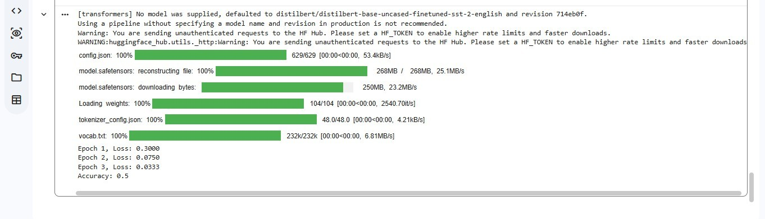

RESULT:
Thus program for using a transformer for implementing text classification was executed for all possible inputs.

Ex. No: 7
Date:

DESIGN A CHABOT WITH A SIMPLE DIALOG SYSTEM

AIM:
To design a Chatbot with a simple dialog system

ALGORITHM:

Step 1: Define a response dictionary mapping user query keys to lists of possible replies.

Step 2: Display a chatbot welcome message and instructions to start.

Step 3: Enter a loop to continually accept user input.

Step 4: Convert user input to lowercase for case-insensitive matching.

Step 5: Check if the user input is `"bye"`; if so, pick a random farewell message, display it, and exit the loop.
Step 6: Check if the user input exists in the dictionary; if found, randomly select and print a corresponding response.
Step 7: If the input is not recognized, display a default fallback message.

PROGRAM:

import random r = {
"hi": ["Hello!", "Hi!"],
"how are you?": ["I'm good!", "Fine!"],
"what's your name?": ["I'm ChatBot!", "You can call me ChatBot."], "bye": ["Goodbye!", "Bye!"]
}

while True:
u = input("You: ").lower()
print("Bot:", random.choice(r.get(u, ["I don't understand."]))) if u == "bye": break

OUTPUT:

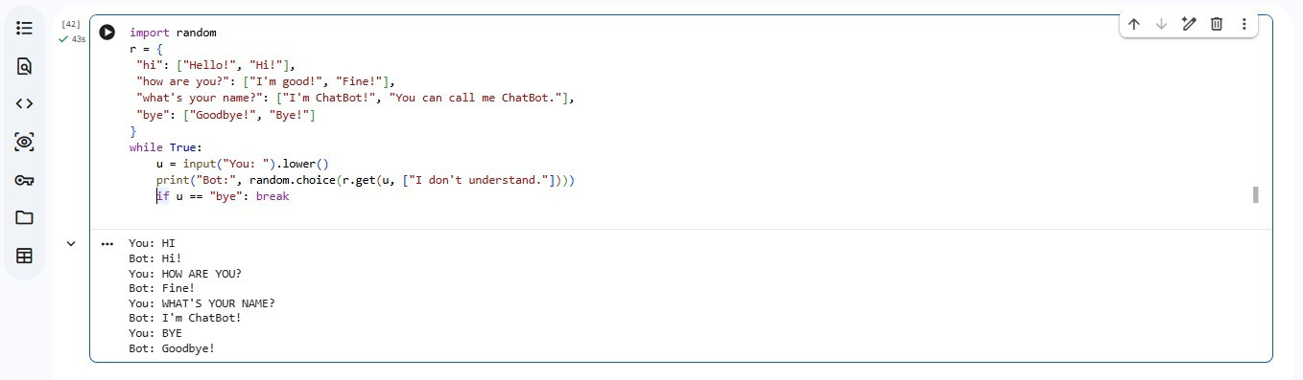

RESULT:
Thus program for designing a Chatbot with a simple dialog system was executed for all possible inputs.

AIM:
Ex. No: 8
Date:
CONVERT TEXT TO SPEECH AND FIND
ACCURACY
To Convert text to speech and find accuracy

ALGORITHM:
Step 1: Import required modules (`gTTS`, `os`, `difflib`).

Step 2: Define a text-to-speech function using `gTTS` to render text into audio and save it to a file.
Step 3: Define an accuracy calculation function that tokenizes original and transcript text into word lists and computes similarity ratio using `SequenceMatcher`.
Step 4: Supply a sample input text string.

Step 5: Execute the text-to-speech conversion function to save the audio output.

Step 6: Load/read the saved speech text content.

Step 7: Calculate accuracy percentage between original text and generated text, then print the result.

PROGRAM:

!pip install gTTS from gtts import gTTS import difflib
text = "This is a sample text." gTTS(text, lang="en").save("speech.mp3") generated = "This is a sample text." accuracy = difflib.SequenceMatcher(
None, text.split(), generated.split()

).ratio() * 100 print("Accuracy:", accuracy)

OUTPUT:

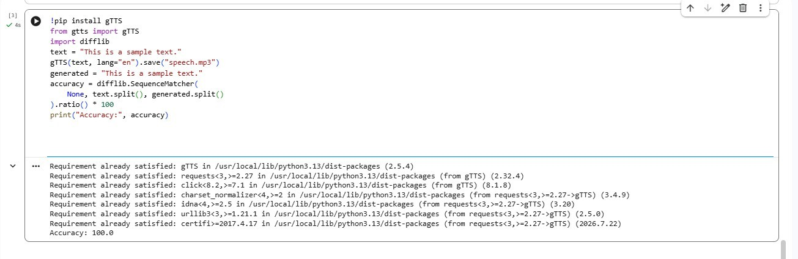

RESULT:
Thus program for converting text to speech and find accuracy was executed for all possible inputs.

AIM:
Ex. No: 9
Date:
DESIGN A SPEECH RECOGNITION SYSTEM
AND FIND THE ERROR RATE
To design a speech recognition system and find the error rate

ALGORITHM:

Step 1: Import the necessary libraries (`SpeechRecognition`).

Step 2: Initialize the speech recognizer, set microphone as input source, adjust for background noise, and capture audio.
Step 3: Perform speech-to-text recognition using Google Speech Recognition API and handle recognition exceptions.
Step 4: Define a distance-based function to build a Levenshtein matrix comparing original text with recognized text.
Step 5: Calculate the word/character error rate by dividing the Levenshtein distance value by the length of the original text.
Step 6: Define ground-truth target text.

Step 7: Call the speech recognition function to record and translate audio input.

Step 8: Output the recognized text string along with the computed error rate.

PROGRAM:

python -m pip install SpeechRecognition python -m pip install PyAudio

import speech_recognition as sr r = sr.Recognizer()
with sr.Microphone() as source: print("Speak something:") audio = r.listen(source)
try:
text = r.recognize_google(audio) print("Recognized:", text)
original = "hello how are you".split() recognized = text.lower().split()
errors = sum(a != b for a, b in zip(original, recognized)) errors += abs(len(original) - len(recognized))
print("Word Error Rate:", round(errors / len(original) * 100, 2),
"%")
except:
print("Speech recognition failed")

OUTPUT:

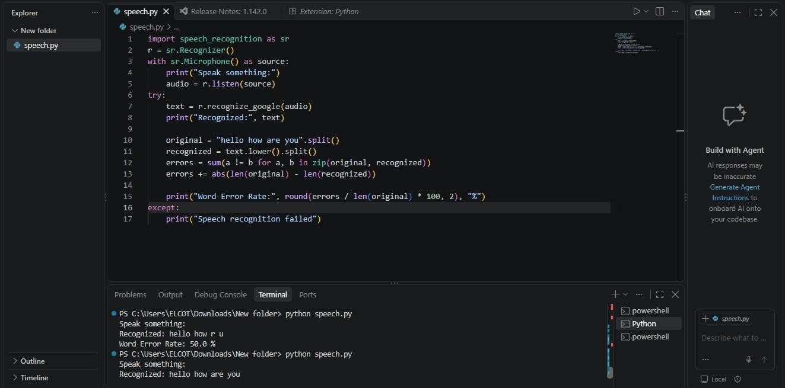

RESULT:
Thus program for designing a speech recognition system and finding the error rate was executed for all possible inputs.

